Meeting Minutes – Project Planning Discussion
Key Points Discussed
- Dataset Approach: Elias suggested that we could explore an online dataset instead of building one from scratch. The group decided to create the database from zero, using the diagram shared by Elias (photo referenced below). However, everyone will still check whether online information exists for each sub-topic (e.g., lists of artifacts or exhibitions).
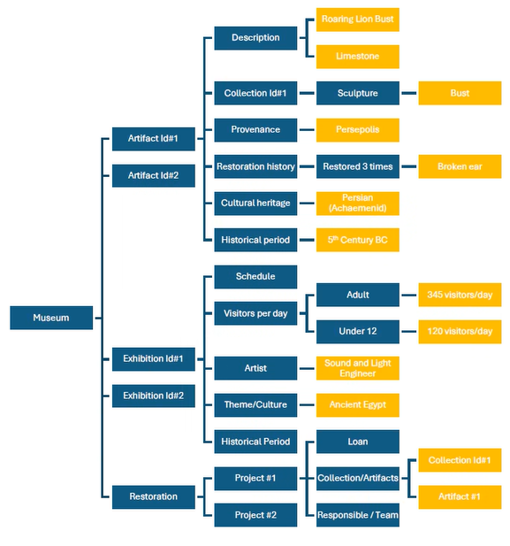
- Task Division:
  - Artifacts: Benoit and Elias will work together.
  - Exhibitions: Trang will take ownership.
  - Restoration: Veronica will lead this part.
- Next Steps: For the next meeting, each person must prepare the database for their assigned section, including its corresponding schema.
- Meeting Cadence: The team agreed to meet every two weeks. The next meeting is scheduled for July 27th at 6:00 PM, with a duration of one hour.
- Collaboration Tools: The group agreed to use GitHub to share all project information and ensure everyone has access. Elias created the project repository and will add all team members as collaborators so everyone can contribute.

